Emotional Intelligence Workshop

Emotional intelligence describes the ability to understand one's own feelings, and that of groups, and how these emotions can influence motivation and behavior. The concepts of Emotional Intelligence have been around since at least the 1900's, but the term was first introduced by Wayne Payne in 1985.

As a result of the growing acknowledgement by professionals of the importance and relevance of emotions to work outcomes, the research on the topic continued to gain momentum, but it wasn't until the publication of Daniel Goleman's best seller *Emotional Intelligence: Why It Can Matter More Than IQ* that the term became widely accepted by mainstream media.

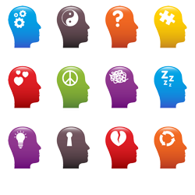**Workshop Objectives:**

* Define and practice self-management, self-awareness, self-regulation, self-motivation, and empathy.
* Understand, use and manage your emotions.
* Verbally communicate with others.
* Successfully communicate with others in a non-verbal manner.
* Identify the benefits of emotional intelligence.
* Relate emotional intelligence to the workplace.
* Balance optimism and pessimism.
* Effectively impact others.

For more information or to reserve your spot in this workshop, please contact:

Tsisk’w Hit Knowledge

[Info@OwlHouseKnowledge.com](mailto:Info@OwlHouseKnowledge.com)

www.owlhouseknowledge.com