**Interpersonal Skills Workshop**

We've all met that dynamic, charismatic person that just has a way with others, and has a way of being remembered. Your participants will identify ways of creating a powerful introduction, remembering names, and managing situations when you’ve forgotten someone’s name.

The Interpersonal Skills workshop will help participants work towards being that unforgettable person by providing communication skills, negotiation techniques, tips on making an impact, and advice on networking and starting conversations. They will also identify the skills needed in starting a conversation, moving a conversation along, and progressing to higher levels of conversation.

**Workshop Objectives:**

* Understand the difference between hearing and listening
* Know some ways to improve the verbal skills of asking questions and communicating with power.
* Understand what is ‘non-verbal communication’ and how it can enhance interpersonal relationships.
* Identify the skills needed in starting a conversation.
* Identify ways of creating a powerful introduction, remembering names, and managing situations when you’ve forgotten someone’s name.
* 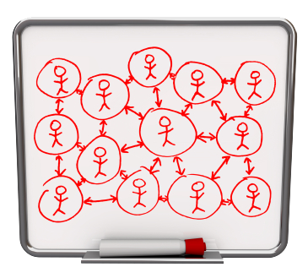Understand how seeing the other side can improve skills in influencing other people.
* Understand how the use of facts and emotions can help bring people to your side.
* Identify ways of sharing one’s opinions constructively.
* Learn tips in preparing for a negotiation, opening a negotiation, bargaining, and closing a negotiation.
* Learn tips in making an impact through powerful first impressions.

For more information on this workshop or to reserve your spot, please contact:

Tsisk’w Hit Knowledge

[Info@OwlHouseKnowledge.com](mailto:Info@OwlHouseKnowledge.com)

www.owlhouseknowledge.com