**Job Search Skills Workshop**

Searching for a job can be intimidating. How do you know what job you're best suited for? How do you build a winning resume and cover letter? Where can you find job leads? How do you network without feeling nervous? What happens when you land an interview? And most importantly, where do you find help when you need it?

The Job Search Skills workshop will give you the answers to all these questions, plus a plan to get you to a new job within a month. After completing this program, you'll be more than ready to start your search for your perfect job. Identifying the purpose for working and the assessment of skills can help determine the types of jobs your participants should apply for.

**Workshop Objectives:**

* Define your objectives and purpose in your search for employment.
* Help you establish SMART goals in the job-hunting process.
* Assist you in developing a first month plan of action for your job search.
* Craft an effective resume.
* Form an attractive cover letter.
* Develop and present a portfolio of your prior work.
* Learn networking skills in finding leads for jobs.
* 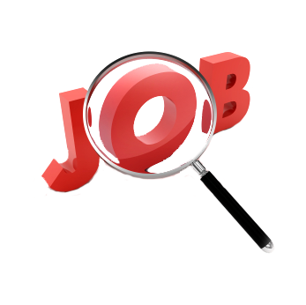Efficiently get interviews and thrive in the interview process.

For more information or to reserve your spot in this workshop, please contact:

Tsisk’w Hit Knowledge

[Info@OwlHouseKnowledge.com](mailto:Info@OwlHouseKnowledge.com)

www.owlhouseknowledge.com