**Proposal Writing Workshop**

A good proposal doesn't just outline what product or service you would like to create or deliver. It does so in such a way that the reader feels it is the only logical choice. Your participants will explore the proposal writing process including the most common types of proposals.   
  
The Proposal Writing workshop will take participants through each step of the proposal writing process, from understanding why they are writing a proposal; to gathering information; to writing and proofreading; through to creating the final, professional product.

**Workshop Objectives:**

* Identify the purpose of a proposal
* Identify different types of proposals
* Identify and perform the steps in the proposal writing process
* Perform a needs analysis and write a goal statement
* Prepare a proposal outline
* Improve their writing skills with a variety of techniques
* Use appropriate resources and ghosting to build a strong case
* 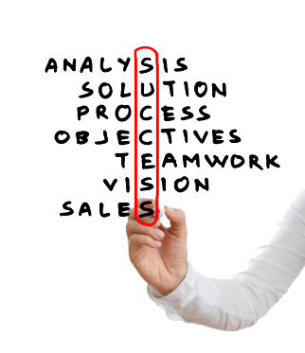Add illustrations to their proposal
* Proofread and edit their proposal
* Add the finishing touches to create a professional-looking final product

For more information or to reserve your spot in this workshop, please contact:

Tsisk’w Hit Knowledge

[Info@OwlHouseKnowledge.com](mailto:Info@OwlHouseKnowledge.com)

www.owlhouseknowledge.com