**Teamwork & Team Building**

For most of us, teamwork is a part of everyday life. Whether it's at home, in the community, or at work, we are often expected to be a functional part of a performing team. Having a strong team will benefit any organization and will lead to more successes than not.   
  
The Teamwork And Team Building workshop will encourage participants to explore the different aspects of a team, as well as ways that they can become a top-notch team performer. Your participants will be given the details and concepts of what makes up a team, and what factors into being a successful team and team member.

**Workshop Objectives:**

* Describe the concept of a team, and its factors for success
* Explain the four phases of the Tuckman team development model and define their characteristics
* List the three types of teams
* Describe actions to take as a leader – and as a follower for each of the four phases (Forming, Storming, Norming and Performing)
* Discuss the uses, benefits and disadvantages of various team-building activities
* Describe several team-building activities that you can use, and in what settings
* 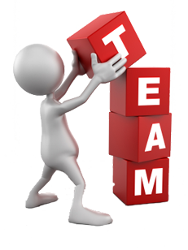Follow strategies for setting and leading team meetings
* Detail problem-solving strategies using the Six Thinking Hats model -- and one consensus-building approach to solving team problems
* List actions to do -- and those to avoid -- when encouraging teamwork

For more information on this workshop or to reserve your spot, please contact:

<Your information>